INDEX:-

S.NO. | NAME OF THE EXPERIMENT | Signature
1. | Create your Own Page with Favorite Hobbies
2. | Chalk out the storyboard and design of Diary Food Limited
3. | Create a Menu or Table of Content Web Page. Each menu item should load a different web page
4. | Create a Web Page Using Ordered and Un-ordered List
5. | Create a Web Page to Show Record of the College in the form of Table
6. | Create a Frameset divided into three sections
7. | Create a Web Page which Displays your Country Link, City and State.
8. | Create a Web Page Using Style Sheet
9. | Create a Calculator using JAVASCRIPT.
10. | Create a Web page using java script to verify a Student Record.

PRACTICAL NO: 1

Create your Own Page with Favorite Hobbies

<HTML>
<HEAD>

<H2 ALIGN = CENTER> Hobbies Page</H2><BR><BR><BR>

</HEAD>
<BODY >
My Hobbies are
<UL>
<Li>Photography<BR><BR>
<Li>Listening Music<BR><BR>
<Li>Playing Games<BR><BR>
<Li>Web Browsing
</UL>
</BODY>
</HTML>
OUTPUT
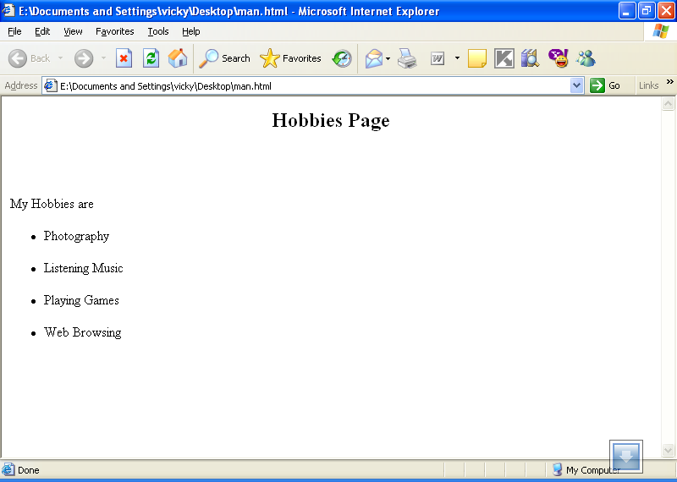

PRACTICAL NO: 2

Chalk out the storyboard and design of Dairy Food Limited.

<HTML>
<HEAD>
<TITLE>

WELCOME TO DAIRY

</TITLE>
</HEAD>

<BODY>

<H1> <CENTER>
WELCOME TO DAIRY
</CENTER> </H1>
<BR> <BR>

<CENTER>
<TABLE BORDER=5 WIDTH=50%>
<CAPTION ALIGN=CENTER><B>DAIRY PRODUCTS</B> </CAPTION>

<TR ALIGN=CENTER>
<TH>PRODUCT CODE
<TH>PRODUCT NAME
</TR>

<TR ALIGN=CENTER>
<TD>001
<TD> <A HREF="MILK.HTML">MILK</A>
</TR>

<TR ALIGN=CENTER>
<TD>002
<TD> <A HREF="CHEESE.HTML">CHEESE</A>
</TR>

<TR ALIGN=CENTER>
<TD>003
<TD> <A HREF="BUTTER.HTML">BUTTER</A>
</TR>
<TR ALIGN=CENTER>
<TD>004
<TD> <A HREF="ICE.HTML">ICE CREAM</A>
</TR>

<TR ALIGN=CENTER>
<TD>005
<TD> <A HREF="MILKSHAKE.HTML">MILK SHAKES</A>
</TR>

</TABLE>
<P>
<P>
<P>
For placing your order
<BR>
Contact : doodhwala@milkdiary.com

</CENTER>
</BODY>
</HTML>

OUTPUT

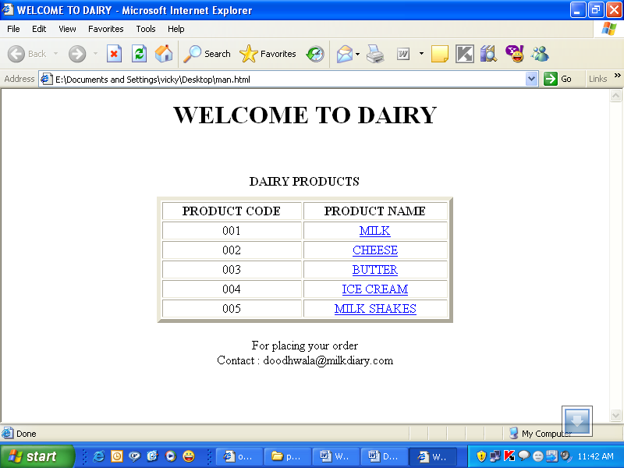

PRACTICAL NO: 2(A)

<HTML>
<HEAD>
<TITLE>
WELCOME TO MILK DAIRY
</TITLE>
</HEAD>
<BODY>
<H1><CENTER>
WELCOME TO MILK DAIRY
</CENTER></H1>
<BR><BR>

<CENTER>
<TABLE BORDER=5 WIDTH=50%>
<CAPTION ALIGN=CENTER><B>MILK TYPES</B></CAPTION>

<TR ALIGN=CENTER>
<TH>PRODUCT CODE
<TH>PRODUCT NAME
<TH>PRODUCT PRICE
</TR>

<TR ALIGN=CENTER>
<TD>1001
<TD>TONED MILK
<TD>Rs 12 PER Kg
</TR>

<TR ALIGN=CENTER>
<TD>1002
<TD>DOUBLE TONED MILK
<TD>Rs 10 PER Kg
</TR>

<TR ALIGN=CENTER>
<TD>1003
<TD>FULL CREAM MILK
<TD>Rs 16 PER Kg
</TR>
</TABLE>
</CENTER>
</BODY>
</HTML>

OUTPUT

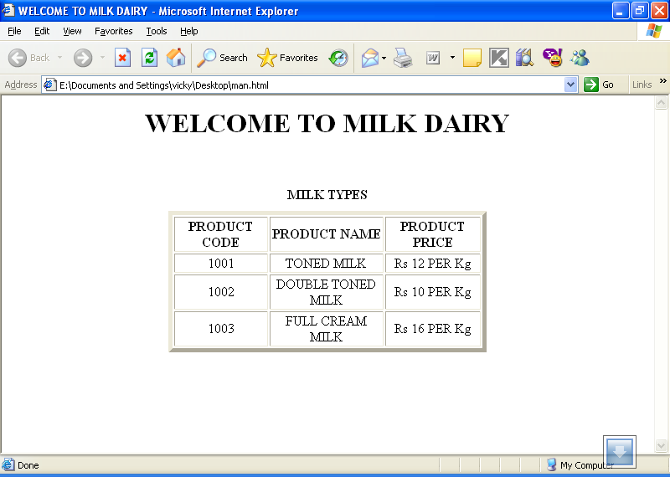

PRACTICAL NO: 2(B)

<HTML>
<HEAD>
<TITLE>
WELCOME TO CHEESE DAIRY
</TITLE>
</HEAD>
<BODY>
<H1><CENTER>
WELCOME TO CHEESE DAIRY
</CENTER></H1>
<BR><BR>
<CENTER>
<TABLE BORDER=5 WIDTH=50%>
<CAPTION ALIGN=CENTER><B>CHEESE TYPES</B></CAPTION>

<TR ALIGN=CENTER>
<TH>PRODUCT CODE
<TH>PRODUCT NAME
<TH>PRODUCT PRICE
</TR>

<TR ALIGN=CENTER>
<TD>2001
<TD>CHEESE
(TYPEI)
<TD>Rs 70 PER Kg
</TR>

<TR ALIGN=CENTER>
<TD>2002
<TD>CHEESE (TYPEII)
<TD>Rs 60 PER Kg
</TR>

<TR ALIGN=CENTER>
<TD>2003
<TD>CHEESE (TYPEIII)
<TD>Rs 50 PER Kg
</TR>
</TABLE>
</CENTER>
</BODY>
</HTML>

OUTPUT

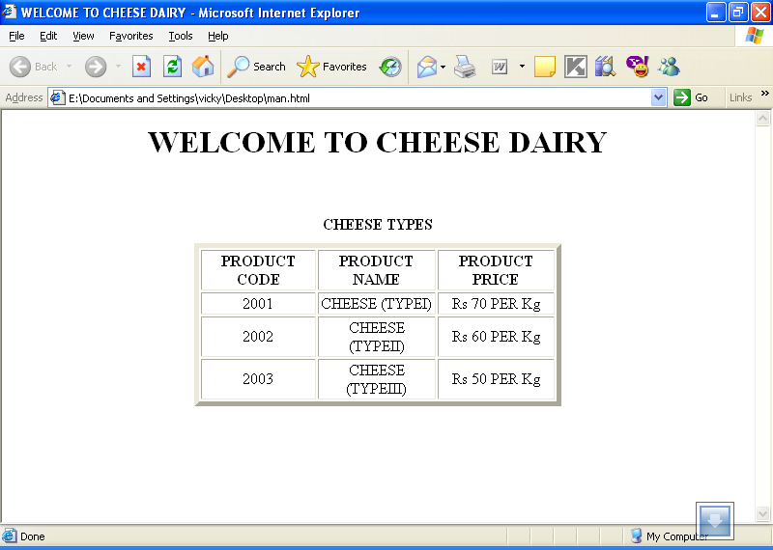

PRACTICAL NO: 2(C)

<HTML>
<HEAD>
<TITLE>
WELCOME TO BUTTER DAIRY
</TITLE>
</HEAD>

<BODY>
<H1><CENTER>
WELCOME TO BUTTER DAIRY
</CENTER></H1>
<BR><BR>

<CENTER>
<TABLE BORDER=5 WIDTH=50%>
<CAPTION ALIGN=CENTER><B>BUTTER TYPES</B></CAPTION>

<TR ALIGN=CENTER>
<TH>PRODUCT CODE
<TH>PRODUCT NAME
<TH>PRODUCT PRICE
</TR>

<TR ALIGN=CENTER>
<TD>3001
<TD>YELLOW BUTTER
<TD>Rs 70 PER Kg
</TR>

<TR ALIGN=CENTER>
<TD>3002
<TD>WHITE BUTTER
<TD>Rs 60 PER Kg
</TR>

</TABLE>
</CENTER>
</BODY>
</HTML>

OUTPUT

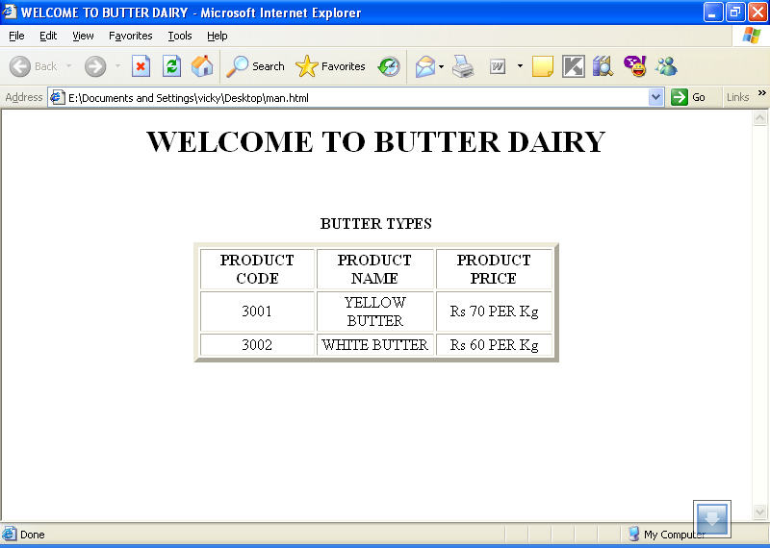

PRACTICAL NO: 2(D)

<HTML>
<HEAD>
<TITLE>
WELCOME TO ICE CREAM SHOP
</TITLE>
</HEAD>

<BODY>
<H1><CENTER>
WELCOME TO ICE CREAM SHOP
</CENTER></H1>
<BR><BR>

<CENTER>
<TABLE BORDER=5 WIDTH=50%>
<CAPTION ALIGN=CENTER><B>ICE CREAM TYPES</B></CAPTION>
<TR ALIGN=CENTER>
<TH>PRODUCT CODE
<TH>PRODUCT NAME
<TH>PRODUCT PRICE
</TR>

<TR ALIGN=CENTER>
<TD>4001
<TD>MILK BAR
<TD>Rs 10
</TR>

<TR ALIGN=CENTER>
<TD>4002
<TD>CHOCO BAR
<TD>Rs 15
</TR>

<TR ALIGN=CENTER>
<TD>4003
<TD>FEAST BAR
<TD>Rs 15
</TR>

<TR ALIGN=CENTER>
<TD>4004
<TD>ORANGE BAR

<TD>Rs 7
</TR>

<TR ALIGN=CENTER>
<TD>4005
<TD>MANGO BAR
<TD>Rs 7
</TR>

<TR ALIGN=CENTER>
<TD>4006
<TD>CASSATA
<TD>Rs 25
</TR>

<TR ALIGN=CENTER>
<TD>4007
<TD>CORNATTO
<TD>Rs 20
</TR>

</TABLE>
</CENTER>
</BODY>
</HTML>

OUTPUT

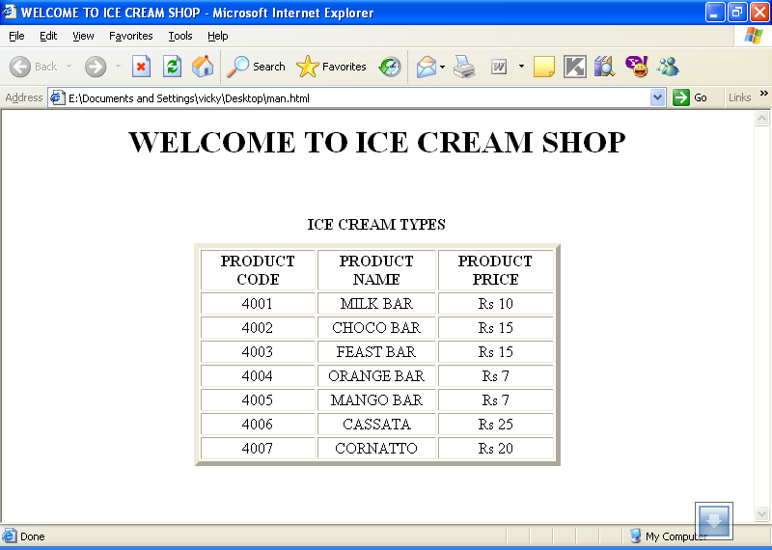

PRACTICAL NO: 2(E)

<HTML>
<HEAD>
<TITLE>
WELCOME TO MILK SHAKES SHOP
</TITLE>
</HEAD>

<BODY>
<H1><CENTER>
WELCOME TO MILK SHAKES SHOP
</CENTER></H1>
<BR><BR>

<CENTER>
<TABLE BORDER=5 WIDTH=50%>
<CAPTION ALIGN=CENTER><B>MILK SHAKES TYPES</B></CAPTION>
<TR ALIGN=CENTER>
<TH>PRODUCT CODE
<TH>PRODUCT NAME
<TH>PRODUCT PRICE
</TR>

<TR ALIGN=CENTER>
<TD>5001
<TD>MILK SHAKE
<TD>Rs 10
</TR>

<TR ALIGN=CENTER>
<TD>5002
<TD>CHOCO SHAKE
<TD>Rs 15
</TR>

<TR ALIGN=CENTER>
<TD>5003
<TD>MANGO SHAKE
<TD>Rs 15
</TR>

<TR ALIGN=CENTER>
<TD>5004
<TD>BANANA SHAKE
<TD>Rs 15
</TR>

<TR ALIGN=CENTER>
<TD>5005
<TD>STRAWBERRY SHAKE
<TD>Rs 20
</TR>
</TABLE>
</CENTER>
</BODY>
</HTML>

OUTPUT

PRACTICAL NO: 3

Create a Menu or Table of Content Web Page. Each menu item should load a different web page

<HTML>
<HEAD>
<TITLE>
WELCOME TO MY MENU
</TITLE>
</HEAD>

<BODY>
<H1><CENTER>
WELCOME TO MY MENU
</CENTER></H1>
<BR><BR>

<CENTER>
<TABLE BORDER=5 WIDTH=50%>
<CAPTION ALIGN=CENTER><B>MENU SECTIONS</B></CAPTION>

<TR ALIGN=CENTER>
<TH>SECTION CODE
<TH>SECTION NAME
</TR>

<TR ALIGN=CENTER>
<TD>001
<TD><A HREF="FLOPPY.HTML">FLOPPY</A>
</TR>

<TR ALIGN=CENTER>
<TD>002
<TD><A HREF="MONITOR.HTML">MONITOR</A>
</TR>

</TABLE>
</CENTER>
</BODY>
</HTML>

OUTPUT

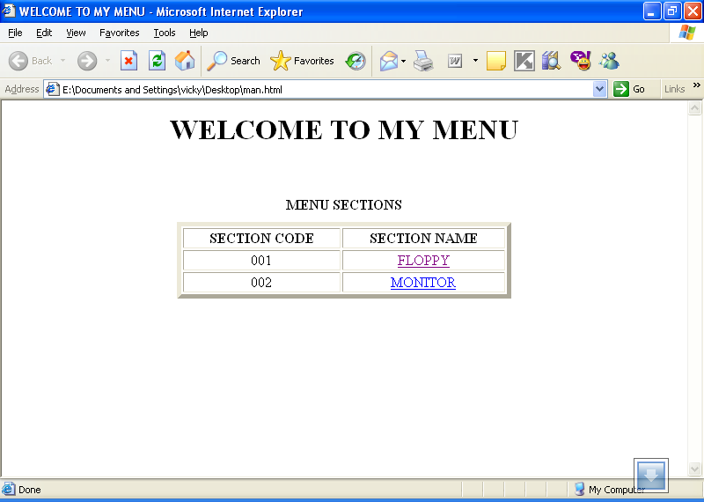

PRACTICAL NO: 3(A)

<HTML>
<H1 ALIGN=CENTER>
FLOPPY DISK
</H1>
<BODY><CENTER>
<IMG BORDER=3 SRC="FLOPPY. jpg" ></CENTER>
<P>
A soft magnetic disk. It is called floppy because it flops if you wave it (at least, the 5¼-inch variety does). Unlike most hard disks, floppy disks (often called floppies or diskettes) are portable, because you can remove them from a disk drive. Disk drives for floppy disks are called floppy drives. Floppy disks are slower to access than hard disks and have less storage capacity, but they are much less expensive. And most importantly, they are portable.
Floppies come in three basic sizes:
<UL>
<LI>8-inch
The first floppy disk design, invented by IBM in the late 1960s and used in the early 1970s as first a read-only format and then as a read-write format. The typical desktop/laptop computer does not use the 8-inch floppy disk.
<LI>5¼-inch
The common size for PCs made before 1987 and the predecessor to the 8-inch floppy disk. This type of floppy is generally capable of storing between 100K and 1.2MB (megabytes) of data. The most common sizes are 360K and 1.2MB.
<LI>3½-inch
Floppy is something of a misnomer for these disks, as they are encased in a rigid envelope. Despite their small size, microfloppies have a larger storage capacity than their cousins -- from 400K to 1.4MB of data. The most common sizes for PCs are 720K (double-density) and 1.44MB (high-density). Macintoshes support disks of 400K, 800K, and 1.2MB.

</UL>
</P>
</BODY>
</HTML>

OUTPUT

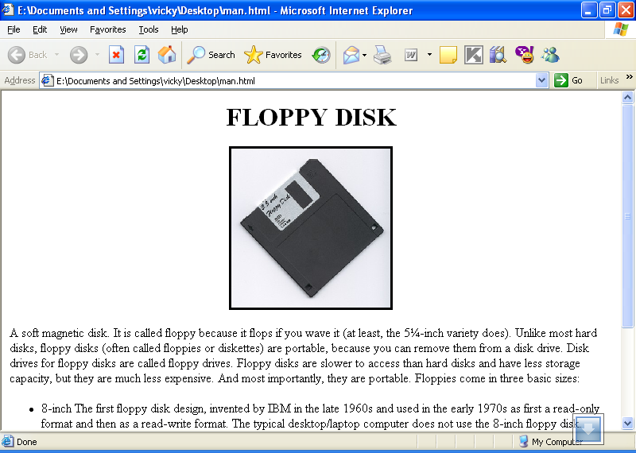

PRACTICAL NO: 3(B)

<HTML>

<BODY>
<H1 ALIGN=CENTER>
MONITOR
</H1>

<P>
Monitor, the display is the most-used output device on a computer. The display provides instant feedback by showing you text and graphic images as you work or play. Most desktop displays use a cathode ray tube (CRT), while portable computing devices such as laptops incorporate liquid crystal display (LCD), light-emitting diode (LED), gas plasma or other image projection technology. Because of their slimmer design and smaller energy consumption, monitors using LCD technologies are beginning to replace the venerable CRT on many desktops.
<BR>
<B>DISPLAY TECHNOLOGY BACKGROUND</B>

Displays have come a long way since the blinking green monitor in text-based computer systems of the 1970s. Just look at the advances made by IBM over the course of a decade:

<UL>
<LI>In 1981, IBM introduced the Color Graphics Adapter (CGA), which was capable of rendering four colors, and had a maximum resolution of 320 pixels horizontally by 200 pixels vertically.
<LI>IBM introduced the Enhanced Graphics Adapter (EGA) display in 1984. EGA allowed up to 16 different colors and increased the resolution to 640x350 pixels, improving the appearance of the display and making it easier to read text.
<LI>In 1987, IBM introduced the Video Graphics Array (VGA) display system. Most computers today support the VGA standard and many VGA monitors are still in use.
<LI>• IBM introduced the Extended Graphics Array (XGA) display in 1990, offering 800x600 pixel resolution in true color (16.8 million colors) and 1,024x768 resolution in 65,536 colors.
</UL>
Most displays sold today support the Ultra Extended Graphics Array (UXGA) standard. In the next section, you'll learn about UXGA.
</P>
</BODY>
</HTML>

\

OUTPUT

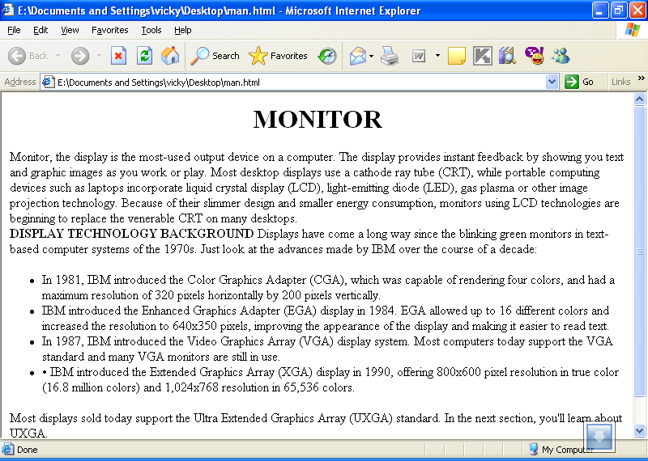

PRACTICAL NO: 4

Create a Web Page Using Ordered and Un-ordered List.

<html>
<head>
<title>
Ordered and Unordered List
</title>
</head>
<body>
<center>
<p>
<b>My Good and Best Friends</b>
</p>
</center>
<ol>
<li>Navendu Rai
<li>Shalini Gupta
<li>Surbhi Sarda
<li>Vinkal Bansal
<li>Mohit Saharan
<li>Aastha Sharma
<li> Neha Awasthi
</ol>

<center>
<b>
Subjects
</b>
</center>
<ul>
<li>SMCS
<li>Compiler Design
<li>Web Engineering
<li>Unix and Linux Programming
<li>SPM
</ul>
</body>
</html>

OUTPUT

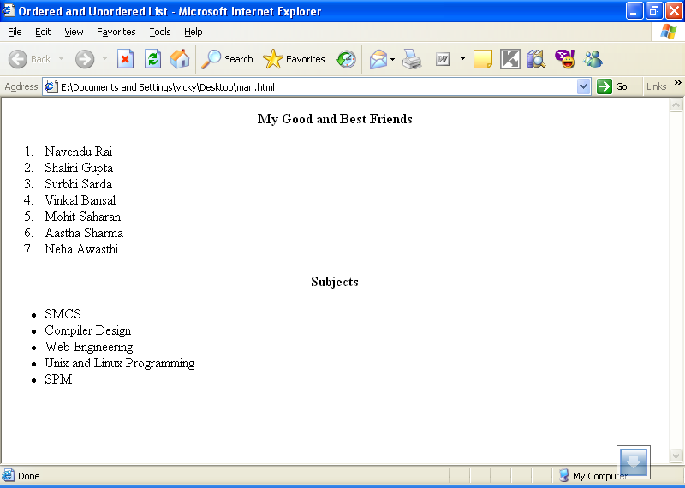

PRACTICAL NO: 5

Create a Web Page to Show Record of the College in the form of Table

<html>
<head>
<title>
College Records
</title>
<head>
<center>
<h1> COLLEGE RECORD</h1>
</center>
<table border=”2” align=”center” width=”50”>
<tr><th colspan=”5” align=”center”>BARWALA</th>
</tr>
<tr>
<td>BRANCH</td>
<td>NO. OF STUDENTS</td>
<td>NAME OF HOD’S</td>
</tr>

<tr>
<td>IT </td>
<td>60</td>
<td>C.P</td>
</tr>

<tr>
<td>CSE </td>
<td>90</td>
<td>K.G</td>
</tr>

<tr>
<td>ECE </td>
<td>120</td>
<td>SARIKA</td></tr>

</table>
</body>
</html>

OUTPUT

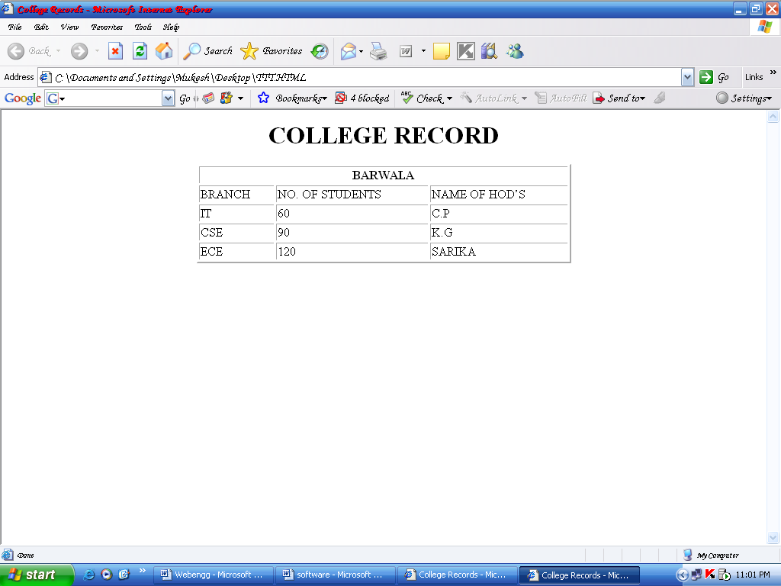

PRACTICAL NO: 6

Create a Frameset divided into three sections

<HTML>
<FRAMESET ROWS="15%, 70%, 15 %">
<FRAME NAME="TITLE" SRC="TITLE.HTML">
<FRAME NAME="DETAIL">
<FRAME NAME="HYPER" SRC="HYPER.HTML" >
</FRAMESET>
</HTML>
____________________________________________________________________________________

<HTML>
<H1 ALIGN=CENTER><B>WELCOME TO Title.html</B></H1>
<body>
<center>
This page describes the frameset and provides information regarding FLOPPY & MONITOR
</center>
</body>
</HTML>

____________________________________________________________________________________

<HTML>
<HEAD>
<TITLE>
HYPER.HTML
</HEAD>
</HTML>
<BODY>
<A HREF=”MONITOR.HTML” TARGET=”DETAIL”>MONITOR</A><BR>
<A HREF=”FLOPPY.HTML” TARGET=”DETAIL”>FLOPPY DISK</A>
</BODY>
</HTML>

____________________________________________________________________________________

<HTML>
<H1 ALIGN=CENTER>
MONITOR
</H1>
<BODY>

<P>
Monitor, the display is the most-used output device on a computer. The display provides instant feedback by showing you text and graphic images as you work or play. Most desktop displays use a cathode ray tube (CRT), while portable computing devices such as laptops incorporate liquid crystal display (LCD), light-emitting diode (LED), gas plasma or other image projection technology. Because of their slimmer design and smaller energy consumption, monitors using LCD technologies are beginning to replace the venerable CRT on many desktops.
<BR>
<B>DISPLAY TECHNOLOGY BACKGROUND</B>

Displays have come a long way since the blinking green monitor in text-based computer systems of the 1970s. Just look at the advances made by IBM over the course of a decade:

<UL>
<LI>In 1981, IBM introduced the Color Graphics Adapter (CGA), which was capable of rendering four colors, and had a maximum resolution of 320 pixels horizontally by 200 pixels vertically.
<LI>IBM introduced the Enhanced Graphics Adapter (EGA) display in 1984. EGA allowed up to 16 different colors and increased the resolution to 640x350 pixels, improving the appearance of the display and making it easier to read text.
<LI>In 1987, IBM introduced the Video Graphics Array (VGA) display system. Most computers today support the VGA standard and many VGA monitors are still in use.
<LI>• IBM introduced the Extended Graphics Array (XGA) display in 1990, offering 800x600 pixel resolution in true color (16.8 million colors) and 1,024x768 resolution in 65,536 colors.
</UL>
Most displays sold today support the Ultra Extended Graphics Array (UXGA) standard. In the next section, you'll learn about UXGA.
</P>
</BODY>
</HTML>

<HTML>
<BODY>
<H1 ALIGN=CENTER>
FLOPPY DISK
</H1>
<CENTER>
<IMG BORDER=3 SRC="FLOPPY.gif" ></CENTER>
<P>
A soft magnetic disk. It is called floppy because it flops if you wave it (at least, the 5¼-inch variety does). Unlike most hard disks, floppy disks (often called floppies or diskettes) are portable, because you can remove them from a disk drive. Disk drives for floppy disks are called floppy drives. Floppy disks are slower to access than hard disks and have less storage capacity, but they are much less expensive. And most importantly, they are portable.
Floppies come in three basic sizes:
<UL>
<LI>8-inch
The first floppy disk design, invented by IBM in the late 1960s and used in the early 1970s as first a read-only format and then as a read-write format. The typical desktop/laptop computer does not use the 8-inch floppy disk.
<LI>5¼-inch
The common size for PCs made before 1987 and the predecessor to the 8-inch floppy disk. This type of floppy is generally capable of storing between 100K and 1.2MB (megabytes) of data. The most common sizes are 360K and 1.2MB.

<LI>3½-inch
Floppy is something of a misnomer for these disks, as they are encased in a rigid envelope. Despite their small size, microfloppies have a larger storage capacity than their cousins -- from 400K to 1.4MB of data. The most common sizes for PCs are 720K (double-density) and 1.44MB (high-density). Macintoshes support disks of 400K, 800K, and 1.2MB.

</UL>
</P>
</BODY>
</HTML>

OUTPUT

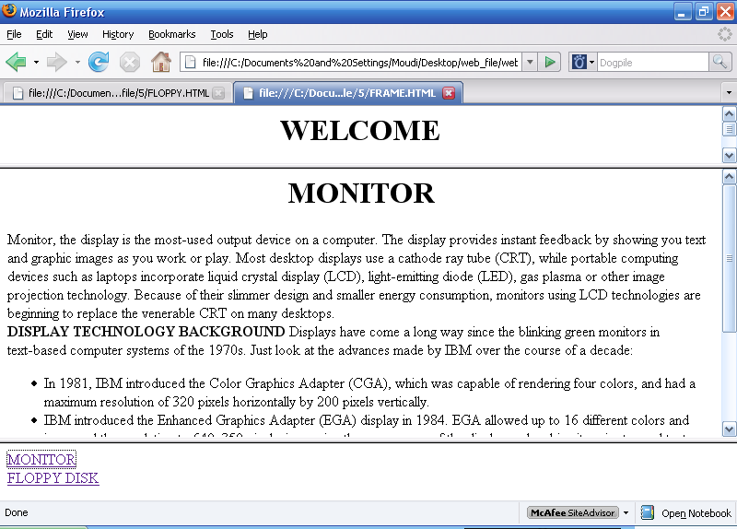

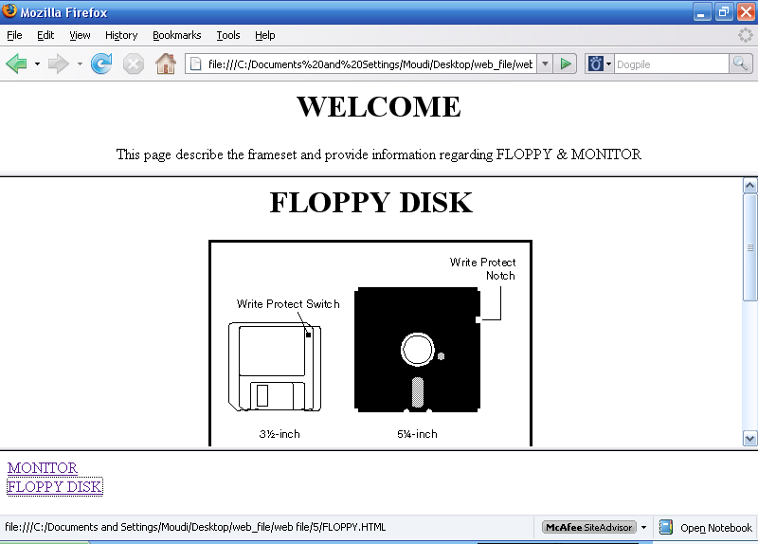
PRACTICAL NO: 7

Create a Web Page which Displays your Country Link, City and State

<html>
<head>
<title>
Map</title>
</head>

<body>
<h1>State:</h1>
<a href="haryana.html">Haryana</a>
<a href="punjab.html">Punjab</a>
<a href="delhi.html">Delhi</a>
</body>
</html>

<html>
<title>
Haryana
<html>
<title>
Haryana
</title>
</head>
<body>
<b>
Haryana:
</b>
<form>
<select name=City>
<option>Ambala
<option>Panchkula
<option>Jind
<option>Karnal
<option>Kurukshetra
<option>Panipat
<option>Bahadurgarh
<option>Hissar
</select>
</form>
</body>
</html>

OUTPUT

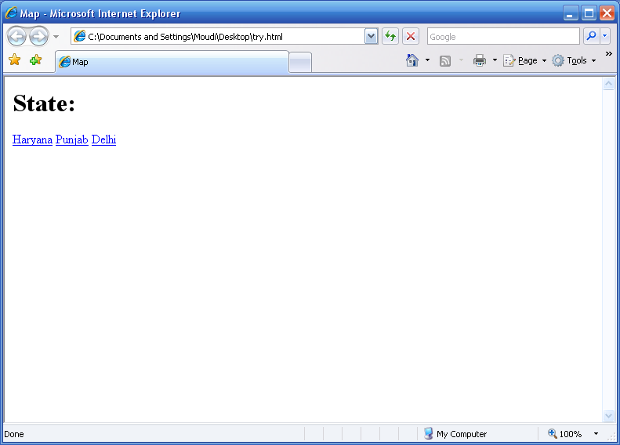

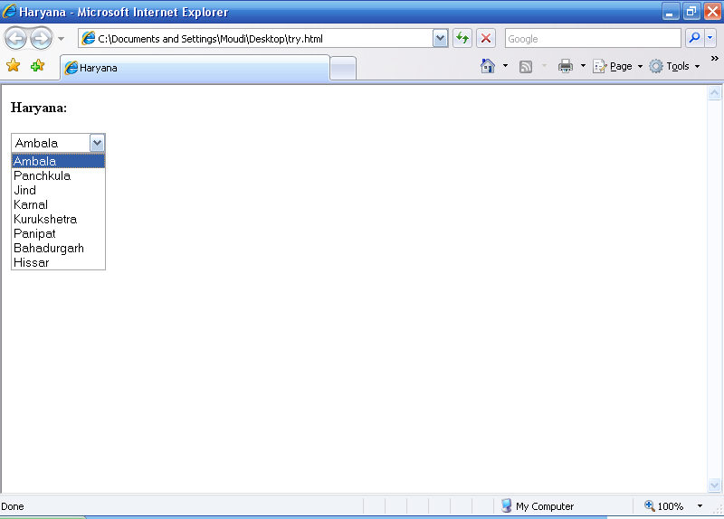

PRACTICAL NO: 8

Create a Web Page Using Style Sheet

<html>
<head><title>Working with style sheets style sheet</title>
<style type="text/css">

h1 {font-family: arial; font-size: 26pt}
p {color:white;background-color:black;font-style:italic}
h4 {text-align: justify}
a {text-decoration: none}
</style>
</head>
<body>
<h1>WiFi Security</h1>
<p>WiFi hotspots can be open or secure. If a hotspot is open, then anyone with a WiFi card can access the hotspot. If it is secure, then the user needs to know a WEP key to connect.
WEP stands for Wired Equivalent Privacy, and it is an encryption system for the data that 802.11 send through the air. WEP has two variations: 64-bit encryption (really 40-bit) and 128-bit encryption (really 104-bit). 40-bit encryption was the original standard but was found to be easily broken (see this page for an explanation). 128-bit encryption is more secure and is what most people use if they enable WEP.

<h4>On the newest machines, an 802.11 card will automatically connect with an 802.11 hotspot and a network connection will be established. As soon as you turn on your machine, it will connect and you will be able to browse the Web, send email, etc. using WiFi. On older machines you often have to go through this simple 3-step process to connect to a hotspot:
Access the software for the 802.11 card -- normally there is an icon for the card down in the system tray at the bottom right of the screen.
Click the "Search button" in the software. The card will search for all of the available hotspots in the area and show you a list.
Double-click on one of the hotspots to connect to it.
On ancient 802.11 equipment, there is no automatic search feature. You have to find what is known as the SSID of the hotspot (usually a short word of 10 characters or less) as well as the channel number (an integer between 1 and 11) and type these two pieces of information in manually. All the search feature is doing is grabbing these two pieces of information from the radio signals generated by the hotspot and displaying them for you.
</h4>
<a href="wifi.html">This is a hyperlink</a>

</body>
<html>

OUTPUT

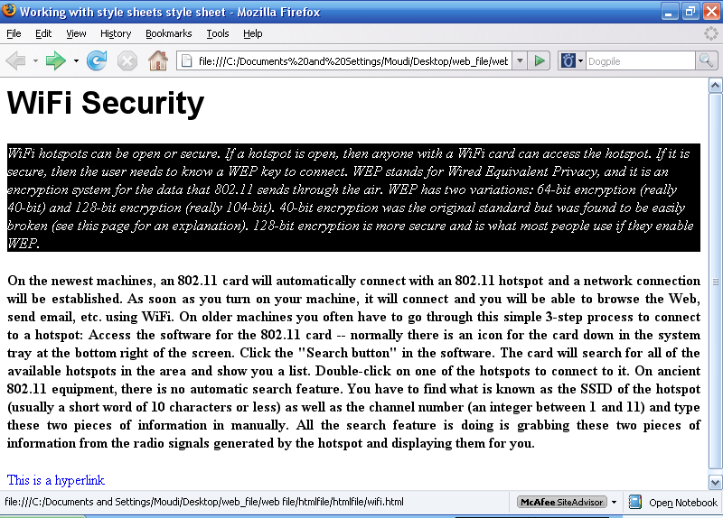

PRACTICAL NO: 9

Create a calculator Using JAVASCRIPT

<html>
<head>

<title>Developing an html page that evaluates an expression</title>

<script language="JavaScript">

function calculate(form)
{
form.results.value=eval(form.entry.value);
}
</script>

</head>

<body>

<form>

<br><br>
Enter a Javascript Mathematical Expression:
<input type="text" name="entry" value="">
<input type="button" value="Calculate" onclick="calculate(this.form) ;">
<br>

The result of this expression is:
<input type="text" name="results" onfocus="this.blur ( ) ;">
<br>
</form>

</body>

</html>

OUTPUT

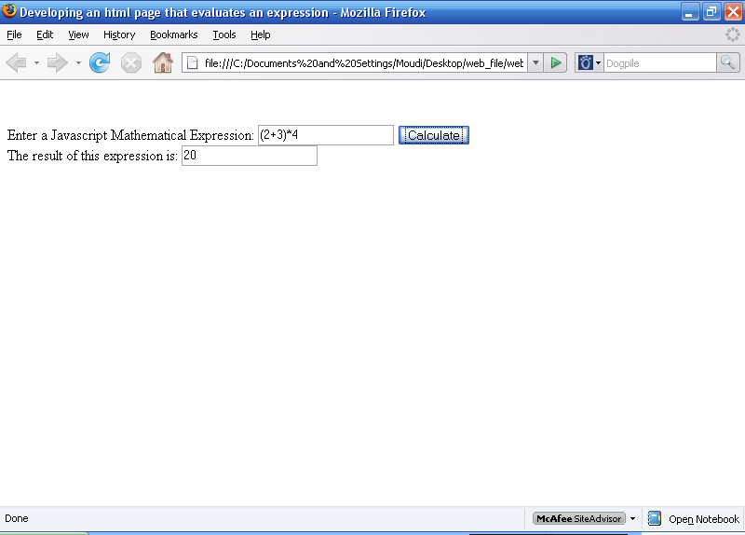

PRACTICAL NO: 10

Create a Web page using JavaScript to Verify a Student Record.

<html>
<head>
<script language="JAVASCRIPT">
function verifydata()
{
a=0; r="";
for (i=0; i<=4;i++)
{
if(document.forms[0].elements[i].value=="")
{
a=1;
r=r+" "+document.forms[0].elements[i].name+";";
}
else if((i>3)&&(a==0))
{
alert("All Textboxes are filled in - Thank You !");
} }
for(i=0;i<=4;i++)
{
if(document.forms[0].elements[i].value=="")
{
alert("Please fill in the following Textbox/Textboxes:-"+r);
document.forms[0].elements[i].focus();
break;
}}}
</script>
</head>
<body>

<form>
First Name:<input type="text" name="Firstname" size=20>
Last Name:<input type="text" name="Lastname" size=20><p>
Address: <input type="text" name="Address" size=60><p>
Pincode: <input type="text" name="Pincode" size=6><p>
<input type="button" name="act" value="Verify" onclick="verifydata()">
</form>
</body>
<script language="javascript">
document.forms[0].Firstname.focus();
</script>
</html>

OUTPUT

